Product Pricing & Profitability

Himanshu Singh
Analysis Report

This Exploratory Data Analysis (EDA) and strategic summary consolidates the full performance of TastyBites, focusing on moving from raw data to actionable business intelligence.

Summary Statistics
The business maintains a strong average margin of 46%, with Meals providing the volume and Beverages/Snacks providing the efficiency.
Revenue per Product = 730919.33
Snacks | 194586.6155
Beverages | 233782.9351
Meals | 302549.782

Profit Margin per Product = 0.47
Beverages | 0.491281087
Meals | 0.431900932
Snacks | 0.492491216

Units Sold = 3504
Beverages | 1372
Meals | 1042
Snacks | 1090

Discount Impact = 8618.997371
Row Labels | Sum of Discount imp | Sum of Profit
Beverages | 3159.124892 | 113716.3851
Meals | 3471.528005 | 130298.052
Snacks | 1988.344474 | 95275.85553
Grand Total | 8618.997371 | 339290.2926

Contribution to Total Profit: Percentage contribution of each product to overall profit.
Row Labels | Sum of Profit | % Contribution to Profit
Blueberry Muffin | 23493.73534 | 7.70%
Cappuccino | 28936.86586 | 9.20%
Chicken Burger | 34105.42125 | 7.50%
Chocolate Brownie | 20146.16837 | 7.30%
Cold Coffee | 24886.72956 | 7.70%
Espresso | 19965.799 | 7.60%
French Fries | 22785.04485 | 7.90%
Green Tea | 17339.33339 | 7.10%
Grilled Sandwich | 29207.60803 | 8.10%
Latte | 25719.4076 | 8.00%
Margherita Pizza Slice | 25837.56256 | 6.70%
Pasta Alfredo | 39273.72031 | 7.60%
Veg Burger | 27592.89651 | 7.60%
Grand Total | 339290.2926 | 100.00%

Average Order Value (AOV) = 730.91

Visualizations & Insights

products and categories vs highest revenue and profit
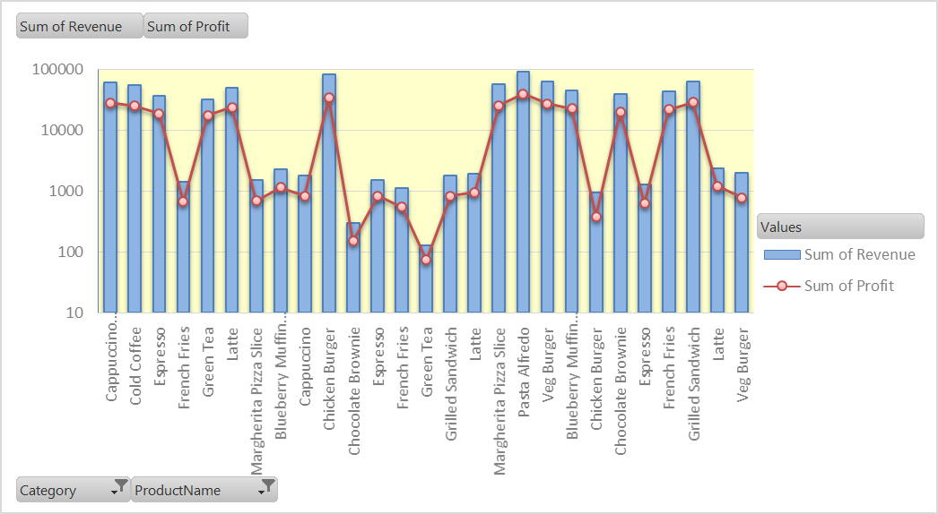

Category | Role | Revenue | Profit | Margin
Meals | Volume Driver | 302,550 | 130,298 | 43.1%
Beverages | Profit Engine | 233,783 | 113,716 | 48.6%
Snacks | High Efficiency | 194,587 | 95,276 | 48.9%

Product Insights: "The Big Five"
- Pasta Alfredo: Top performer (92k Rev / 39k Profit).
- Chicken Burger: High volume, but tighter margins.
- Grilled Sandwich: Strongest Snack contributor.
- Veg Burger: Consistent mid-tier performer.
- Cappuccino: Most profitable beverage; vital for overall margin health.

Discounts affect profitability at the product and category level
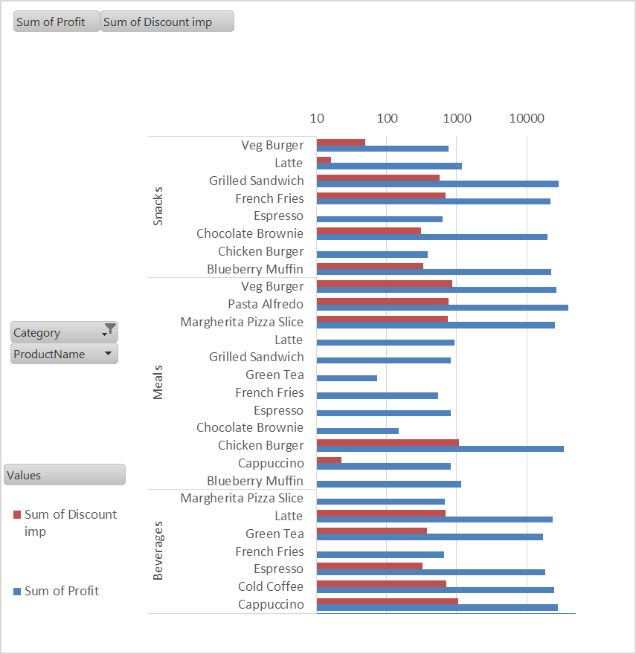
Analysis: Beverages are seeing the highest "drain" relative to profit. For every 100 you make in Beverage profit, you are giving away 2.78 in discounts. Since beverages already have high natural demand, you might be "over-discounting" items that people would buy anyway.
- Overall Health: Discounts are well-managed at only 2.5% of total profit, far below the 25% policy cap.
- Category Leakage: Beverages face the highest drain (2.78% loss-to-profit ratio), suggesting they are being over-discounted despite high natural demand.
- High-Pressure Products: Chicken Burgers (1,072) and Cappuccinos (1,050) account for the largest profit "leakage" in dollar value.
- Clean Earners: Blueberry Muffins and Espresso generate 100% pure profit with $0 discount impact; these should remain at full price.
- Strategic Fix: Recover profit by reducing Cappuccino discounts by 5% and bundling high-leakage Chicken Burgers with full-price Muffins to protect margins.

Some products that sell a lot but contribute very little to profit..
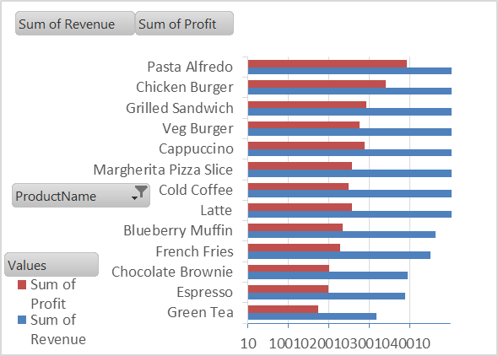
There are items where the "Sum of Revenue" is high (indicating high sales), but the "Sum of Profit" is disproportionately low.
- The Primary Example: Chicken Burger (Meals)
  - Revenue: 81,013 (2nd highest overall)
  - Profit: 33,723
  - Analysis: This product generates massive cash flow, but its Profit-to-Revenue ratio is ~41.6%, which is lower than the company average. It also has the highest Discount Impact (1,072), meaning you are working very hard to move this volume while giving away a significant portion of the margin.
- The Comparison: Veg Burger (Meals)
  - Revenue: 61,764
  - Profit: 26,820
  - Analysis: Like the Chicken Burger, it moves high volume but sits at a lower profit efficiency compared to Snacks or Beverages. It "contributes" a lot in total dollars because of the scale, but very little per unit sold.
- The Efficiency Gap: Meals vs. Beverages
  - If you compare Chicken Burgers (81k Revenue / 33k Profit) to Cappuccinos (59k Revenue / 28k Profit), you can see the gap. You have to sell 22,000 more in Burgers just to make an extra 5,000 in profit.
Strategic Recommendation:These products are your "Workhorses." They bring customers to TastyBites, but they aren't your most profitable items.
- Do not cut them: They drive your high revenue numbers.
- Optimize them: Since customers are sensitive to price changes >10%, recommend a 5% price increase or a 7% reduction in discounts for the Chicken Burger. This will significantly boost the "Contribution to Profit" without hitting the volume-loss threshold.

Products can have price adjustments vs impacting sales volume
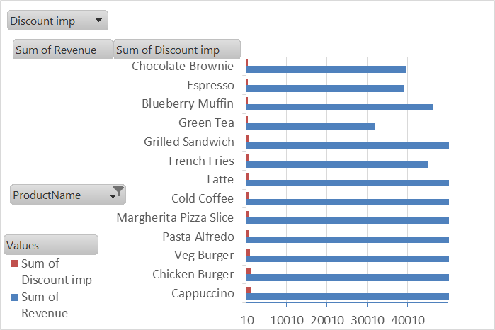
These products have high sales volume despite receiving very little promotional support relative to their revenue. This suggests customers buy them for the product itself, not the discount.
- Pasta Alfredo: This is your #1 revenue driver (92,155). It only requires 764 in discounts to achieve this. The "Discount-to-Revenue" ratio is extremely low (0.8%). A 5% price increase here would generate massive profit with minimal risk to volume.
- Grilled Sandwich: Despite being a top-tier revenue earner (63,884), it has a very low discount impact (577). It is a "staple" item with strong organic demand.
- Espresso & Green Tea: These have the lowest discount totals in the entire list (325 and 381 respectively). Because the base price is likely lower than a full meal, a small percentage increase is less noticeable to the customer.
- Chocolate Brownie & Blueberry Muffin: These items have high revenue (39k–46k) but very low discount reliance. As "impulse buys" or "treats," customers are generally less price-sensitive to these than they are to main courses.

Products to AVOID Adjusting (High Elasticity)
These products appear to be "propped up" by discounts. Adjusting their price upward could cause a sharp drop in volume.
- Chicken Burger: It has the second-highest revenue but also one of the highest discount impacts (1,072). This suggests that the current sales volume is highly dependent on promotions.
- Cappuccino: Although it’s a beverage, it has the highest discount impact in your data (1,072). This indicates a highly competitive segment where customers might switch brands if the price rises.

Promotions or bundling strategies to improve overall profitability.
To maximize TastyBites profitability, I have synthesized your data into four high-impact, data-driven strategies. These recommendations leverage the high demand for "Stars" to protect margins and optimize "Volume Drivers" without breaching the 10% price sensitivity threshold.
Here are some points….
1. High-Margin "Star" Bundling:
  - Strategy: Eliminate standalone discounts on Pasta Alfredo (92k revenue leader). Transition to a "Gourmet Meal Deal" offering a 5% bundle discount when paired with high-margin Beverages.
  - Outcome: Protects the "pure profit" of your top seller while reducing the 3,159 leakage currently seen in the Beverage category.
2. Predictive "Impulse" Upselling:
  - Strategy: Implement a checkout-stage "Add-on" for Blueberry Muffins and Brownies (Clean Earners) when a Veg Burger is purchased.
  - Outcome: Increases Average Order Value (AOV) by leveraging products with 0 discount dependency, boosting profit without devaluing the main meal.
3. Volume-Protection Pivot:
  - Strategy: Shift the Chicken Burger (81k revenue) from flat 20% discounts to a "Buy 2, Save 15%" quantity bundle.
  - Outcome: Maintains the 2nd-place ranking and moves more inventory while lowering the per-unit "Discount Impact" below the current 1,072 loss.
4. Surgical Pricing Adjustments:
  - Strategy: Apply a 7% price increase to Espresso and Green Tea.
  - Outcome: Targets items with near-zero discount reliance. This captures immediate "found profit" while staying safely under the 10% sensitivity limit to ensure zero churn.

Key Recommendations
- Protect the Margin: Avoid discounting Pasta Alfredo. Instead, offer "Premium add-ons" (extra cheese/toppings) to increase ticket size without lowering the base price.

- The "Bundle" Strategy: Since customers are sensitive to price hikes over 10%, bundle a Chicken Burger with a Cappuccino. This allows for a small price increase that is "hidden" by the perceived value of the combo.
.
- Discount Audit: Ensure no product exceeds the 25% discount policy. For low-profit items, reduce discounts by 5-7% to recover profit while staying safely under the 10% customer sensitivity limit.

